**CREATE IBM WATSON IOT PLATFORM & DEVICE**

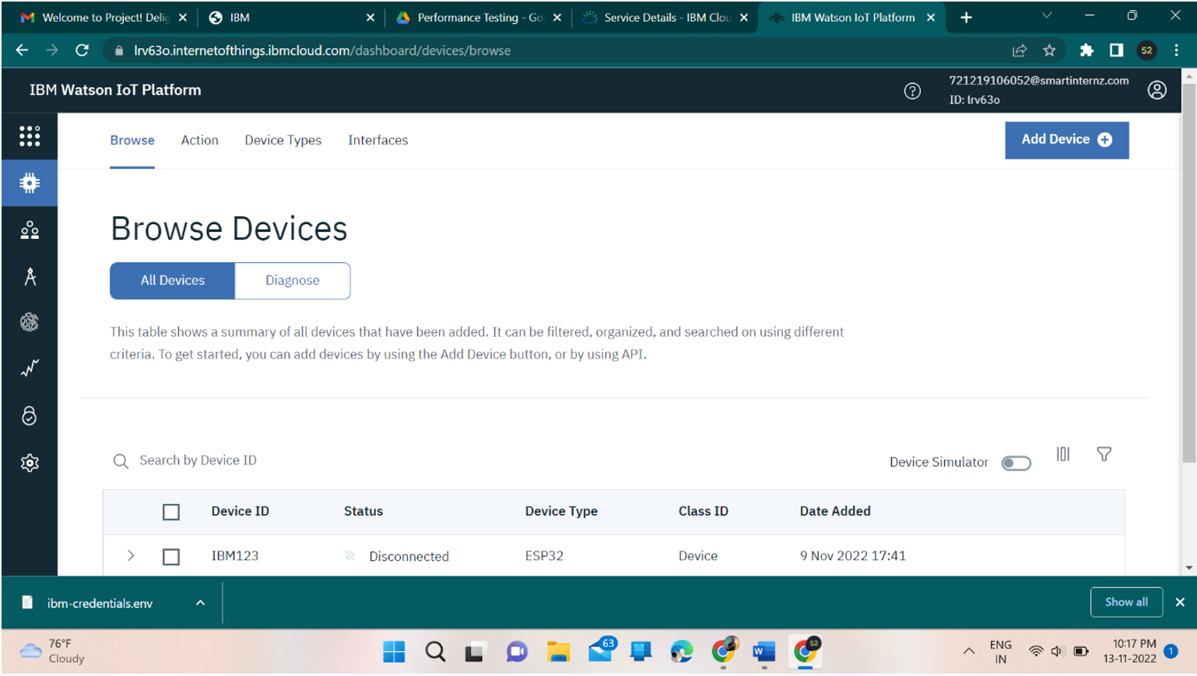

**CREATING IBM WATSON IOT PLATFORM & DEVICE SUCCESSFULLY**